Author: | Calvin Beidleman | Program Type: | Health Initiatives
Event Date (When): | May 4, 2019 | Event Type (What): | Relay for Life
Sponsor (Who): | PsiAA

Location (Where):
Reason (Why): | To raise money and support the fight against Cancer
Were there any of the following? Check all that apply and provide documentation
☐ Media/News Article | ☐ Programs | ☐ Advertisements | ☐ Awards to Chapter/Member | ☐ Other
Other: | Click to enter other.
Article:
On May 4, 2019, the men of Psi Alpha Alpha (PsiAA) Chapter, Third District, Omega Psi Phi Fraternity, Inc. participated in the annual Relay for Life – Vienna Town Green in Vienna Va. Each year, millions of people help raise much-needed funds and awareness to save lives from cancer through the Relay for Life movement by: 1) celebrating cancer survivors and what they've overcome, 2) remembering those lost to the disease, and 3) honoring those who have successfully fought or are fighting cancer.
The PsiAA men raise and contributed $4,546.04 which contributed to the overall event total upwards of $50,000.00 to help the American Cancer Society continue to fund groundbreaking cancer research, free rides to chemo, free places to stay near hospitals, and a live 24/7 helpline for answers and support.

We also used this event as a joint venture to support our following efforts:
- 5k walk as Relay for Life is an event that allows and encourages participants to walk the outlined area. Numerous laps was made by the men, family, and friends of the chapter.
- Voter Registration table was setup to allow residents obtain information and register to vote for this coming election season.
PsiAA’s team members also took advantage of the 8 hours at the event by fellowshipping and enjoying their family and friends in this unique community setting. At sunset, luminaries were lit to remember those that have been lost to cancer and to show those affected by cancer that they are not alone. As part of the closing ceremony, the last lap of the relay was walked in silence.

Photo File Name: DSC_1287 | Photo File Name: DSC_0018
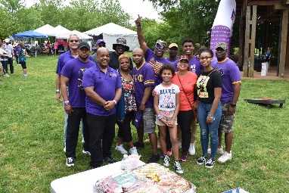 | 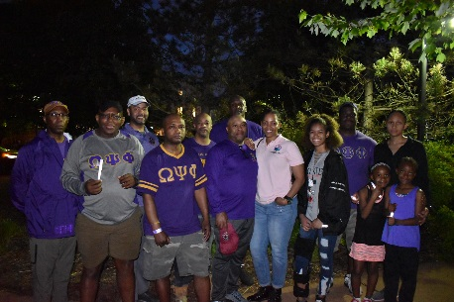
Caption: Brothers family and friends support Relay for Life | Caption: End of event fellowship

Photo File Name: DSC_1297 | Photo File Name: DSC_1321
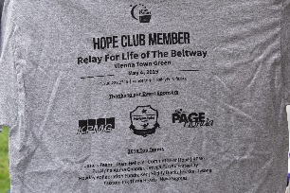 | 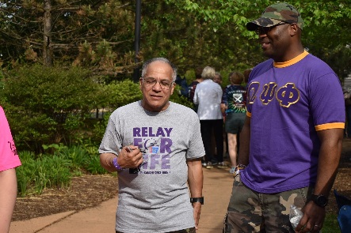
Caption: PsiAA Sponsorship shirt | Caption: Bro Baylor and Bro Ringo in fellowship

